The Impact of Presidential Policies

Harshil Patel

Colorado State University – Global Campus

The Impact of Presidential Policies

The topic I chose to analyze for this project involves looking at 2 democratic and 2 republican presidents and trying to understand what impact their political policies had on the conditions of the people over the course of their terms. The presidents I chose to analyze were George W. Bush Jr., Bill Clinton, Ronald Reagan, and Barack Obama. The reason I chose these 4 is because they are the most recent presidents in history who have all served 2 terms in office. This helps me find more relevant information as certain metrics were only tracked closely in more recent years and gives all the presidents enough time to make a large enough impact to be observed.

**Initial Data Acquisition**

I had to make sure that I was able to extract the data for all my metrics for the first and last year that each of these Presidents were in office so that I could maintain consistency and not have to piece together individual data from multiple sources. I obtained the unemployment level data from the Iowa State University Unemployment Report (Iowa State University, n.d.). Here I took the state report for annual unemployment levels and used this as my layout for the other data I would get with the states as the rows and the years as my columns. I imported my poverty rate data from the US Census Bureau and adapted the formatting to be the same as the formatting for my unemployment level data. I took the real disposable income per capita data from the St. Louis Federal Reserve and used the real disposable income here so that it took inflation into account and didn’t skew my results. Finally, I obtained my GDP from the Bureau of Economic Analysis.

For all this data I had to do the cleaning first in excel since all the data came formatted in different ways. I chose the layout of the unemployment data as the standard format for all the other data because I thought it would be easiest to later split the data in RStudio if it was formatted in that way. I needed to split the data later because I needed to split it up by year to account for the different terms of the Presidents.

**Initial Thoughts and Hypothesis**

Since monetary policy and fiscal policy have different effects in different ways, I have come up with 4 different hypotheses that I will be testing based on the 4 different data sets that I have acquired. My hypotheses are as follows:

1. H0: Democrats will lower the poverty levels more than Republicans

HA: Democrats will lower the poverty levels less than Republicans

1. H0: Democrats will lower the unemployment levels more than Republicans

HA: Democrats will lower the unemployment levels less than Republicans

1. H0: Democrats will increase the GDP less than Republicans

HA: Democrats will increase the GDP more than Republicans

1. H0: Democrats will increase the real per capita income less than Republicans

HA: Democrats will increase the real per capita income more than Republicans

My reason for this line of thinking is that democrats usually enact more policies to help people find employment, gain skills, and provide public goods. Therefore, I assumed that the effects of democratic presidents would help reduce poverty levels and unemployment levels as it would align with their policy changes. Republicans however are staunch defenders of growing business whether it be big or small so I assumed that their monetary and fiscal policies would lead to increases in GDP and per capita income since they’re all about freeing business to work without restrictions leading to boosts in these categories.

**Data Editing**

I first start off my process loading all the libraries I intend to use and importing all my data into RStudio as data frames (lines 1-36). The next important step for me was to split these data frames and acquire the separate data for each President. To do this I took the last year of each President’s term and subtracted it by the numbers that were there during the first year of the President’s term. This way I was able to see what the total impact they had on the variable was over the course of their 8 years in office (lines 39-64). I then pushed all these columns of information into separate data frames for each president (lines 68-72). I prepped these data frames for an inner join with the state boundaries data I’ll get later from the maps library by renaming the region columns and converting it to lowercase (lines 75-90). I used the map_data() function from the maps library to get the plot lines of the states and then inner joined the two data frames together to get data frames for plotting the maps (lines 93-101).

**Visualizations**

Using ggplot2 I worked on creating the maps for each of my visualizations. I created the visualizations for poverty levels (lines 115-133), unemployment levels (lines 136-160), percent change in real per capita income (lines 157-175), and percent change in GDP (lines 178-196). I made sure that for each of the plots the legends would be the same so that we could visually compare all 4 maps without having to account for different scaling based on data available. I then used the grid.arrange() function to help arrange and display the 4 maps related to each topic together so we could visually compare them side by side with the two republican maps on the top row and the two democratic maps on the bottom row (199-215).

1. Based on the visualization of the first map which examines poverty level it may be safe to assume that our null hypothesis that democrats would reduce poverty levels more than republicans was a safe assumption. It shows that under Reagan and Bush the poverty level increased in many states whereas under Obama and Clinton the poverty level was mostly reduced.

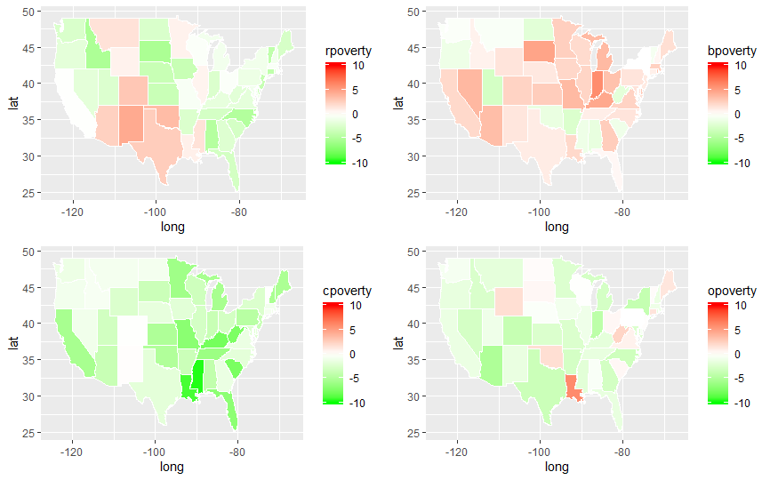

1. Looking at the next map which shows the change in unemployment levels across the US under these Presidents we can once again see that there is a clear distinction between the two republican presidents on the top maps compared to the democrats on the bottom maps. It seems that once again we can assume that our null hypothesis of democrats reducing unemployment levels more than republicans will come out to be true.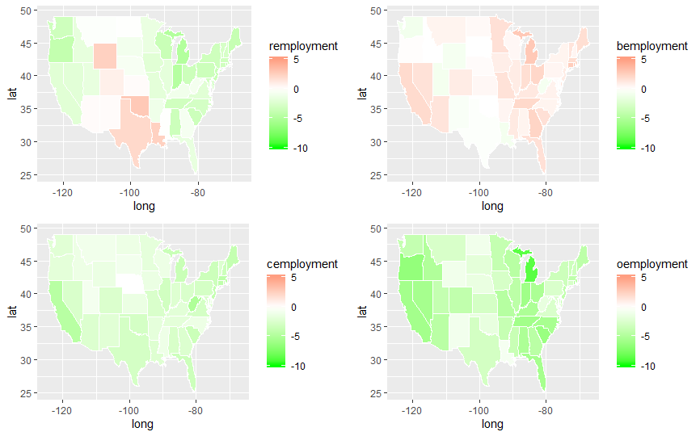
2. Our third map shows us the relationship that the Presidents had on the percent change in GDP levels of the country. This comparison tells us very little in the way of determining if our null hypothesis is true since it doesn’t show a clear edge one way or another towards democratic or republican presidents.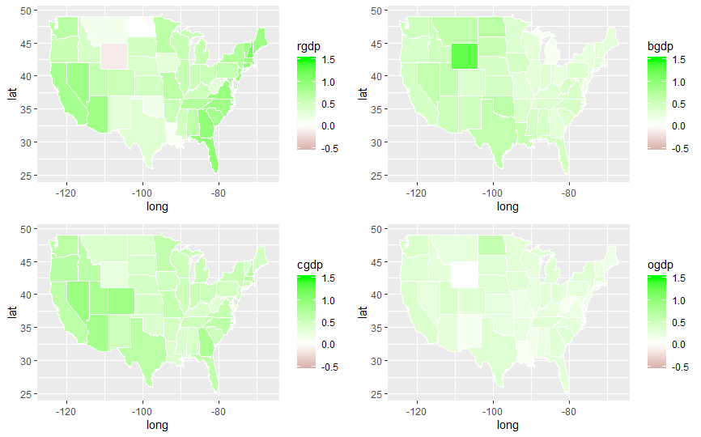
3. Our final map shows us the percent changes in real per capita income under each president. This map is still a bit unreliable since even though it seems the two republican maps on top have the edge in this one, we can’t finalize the conclusion since they seem much closer in comparison than the other maps have. 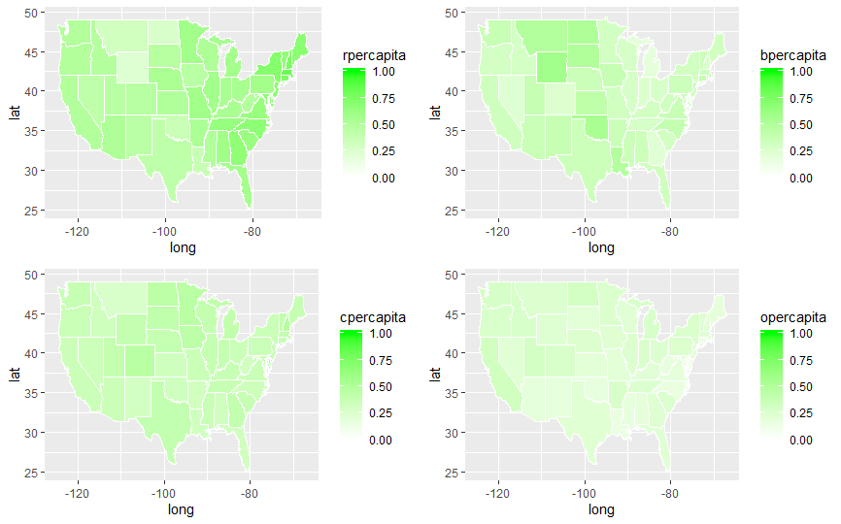

**Hypothesis Testing**

Our final step in this project is to use unpaired 2 sample t-tests to determine whether we can safely confirm our null hypotheses or whether we must reject them in favor of the alternate hypotheses. To do this we must first create a final data frame that combines all our data and classifies it into 2 groups: democrats and republicans (lines 219-248).

1. Our first t-test (lines 250-251) tests whether our null hypothesis of democrats lowering the poverty level more than republicans returns this result
   1. 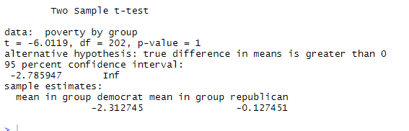
   2. This indicates that we can safely accept the null hypothesis since the p-value is greater than our alpha (0.05).
2. The second t-test (lines 253-254) tests whether our null hypothesis of democrats lowering the unemployment levels more than republicans returns this result
   1. 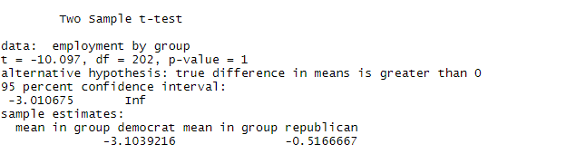
   2. Once again, we can safely accept this null hypothesis as true since the p-value is greater than alpha
3. The third t-test (lines 256-257) tests whether our null hypothesis of democrats increasing the GDP levels less than republicans returns this result
   1. 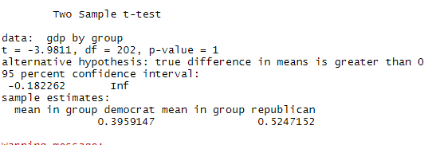
   2. Once again, we can accept the null hypothesis here and a look at the two means of the groups shows how close they are and why identifying this from the maps was a much tougher obstacle than the two maps before
4. The final t-test (lines 259-260) tests whether our null hypothesis of democrats increasing real per capita income levels less than republicans returns this result
   1. 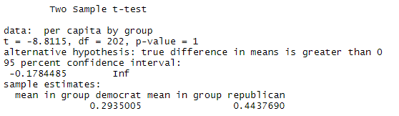
   2. We can accept our null hypothesis and see again the closeness of the two means making visual identification much more difficult.

**Conclusion**

Based on this cursory research and look into presidents and their impact on four major components of the economy it becomes very difficult to tell whether democrats or republicans are better for the economy. Both groups seem to have their advantages depending on what you look at and a much more in-depth study looking at multiple other factors would be necessary to truly classify one as better than the other. What we can say for a fact is that under democrats’ citizens, especially lower income citizens, benefit at a much higher rate since there are clear indications that democrats are much better at reducing poverty levels and unemployment than their republican counter parts. This coupled with the large income inequality across the United States could make a case that democrats may be better for the public since the ratio between lower class Americans and the upper class is highly skewed towards the lower class. We were able to also identify that in terms of economic growth in the form of GDP and real per capita income gives the edge to Republicans most likely due to their business benefit policies.

The one thing that was difficult to consider that could have impacted this research is that the house and senate may or may not have been in control of the presidential party which could hinder or advance the presidents policies. This could have larger impacts on what the final outcomes may look like and in future study would be good to keep in mind.

In conclusion, we were able to confirm that our initial hypotheses were all true by both visual and statistical methods. There is also room in the future for a follow up study to understand the relationships of a variety of indicators on presidential performance and their correlation with political party.

References

Blinder, A., & Watson, M. (2015). Presidents and the U.S. Economy: An Econometric Exploration. doi: 10.3386/w20324

Bureau of Economic Analysis. (n.d.). GDP and Personal Income Data. Retrieved February 5, 2020, from https://apps.bea.gov/itable/iTable.cfm?ReqID=70&step=1#reqid=70&step=1&isuri=1

Current Employment Statistics - CES (National). (2020, January 10). Retrieved January 10, 2020, from <https://www.bls.gov/ces/>.

Federal Reserve Bank of St. Louis. (n.d.). Release Tables: Median Household Income by State, Annual. Retrieved February 5, 2020, from <https://fred.stlouisfed.org/release/tables?rid=249&eid=259462&od=2016-01-01#>

Iowa State University. (n.d.). Annual Unemployment Rates by State. Retrieved February 5, 2020, from https://www.icip.iastate.edu/tables/employment/unemployment-states

Pandey, P. (2019, February 11). A Comprehensive Guide to Data Visualization in R for Beginners. Retrieved January 10, 2020, from https://towardsdatascience.com/a-guide-to-data-visualisation-in-r-for-beginners-ef6d41a34174#e672.

Roth, S. (2018, October 20). Economists Agree: Democratic Presidents are Better at Making Us Rich. Eight Reasons Why. Retrieved January 10, 2020, from <https://evonomics.com/economists-agree-democratic-presidents-better-making-us-rich-eight-reasons/>.

US Census Bureau. (2019, August 27). Historical Poverty Tables: People and Families - 1959 to 2018. Retrieved February 5, 2020, from https://www.census.gov/data/tables/time-series/demo/income-poverty/historical-poverty-people.html